Dimensional analysis Practice
- My dog ran 3.22 km this morning. How many mm did my dog run?

- An alloy is composed of silver and copper. If the alloy is 48.2% silver, how many grams of the alloy are required to provide 75.0 grams of silver?

\
- The distance between San Diego and Dallas is 1906 km. What is this distance in feet?

- The density of bronze is 7.64 g/mL. If a bronze statue has a mass of 15.32 lb, what is the volume of the statue in L?

- The temperature outside is 27ºC. What is this temperature in ºF? In K?

- What is the volume of liquid in the graduated cylinder at the right? (The cylinder is calibrated in mL)
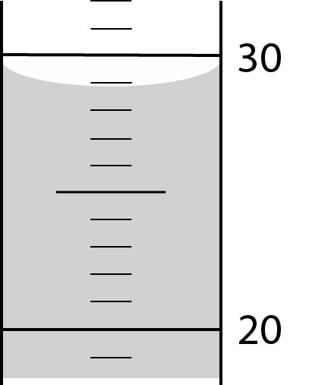

- If 48.5 mL of methanol are produced in a fermentation vat every day, what is the rate of production in gallons of methanol per year? (1 gal = 4 qt)

